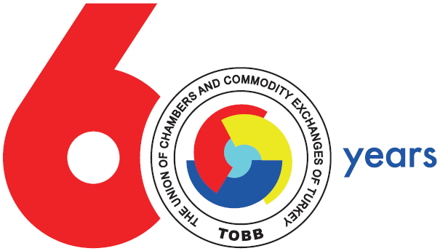



TURKEY-GREECE-BULGARIA THIRD REGIONAL BUSINESS FORUM
20-21 November 2012, Çanakkale
Draft Program
20 November 2012, Tuesday

Arrival of the delegates

21 November 2012, Wednesday

08:00 - 08:30 Transfer to the Congress Hall
08:30 - 09:30 Registiration/ Coffee Break
09:30 - 11:00 Remarks on Cooperation Opportunities by Turkey-Greece-Bulgaria Business Councils

11:00 - 12:30 Opening Speeches

- Mr. Bülend Engin, President of Çanakkale Chamber of Commerce and Industry
- Mr. Tsvetan Simeonov, President of the Bulgarian Chamber of Commerce and Industry
- Mr. Constantinos Michalos, President of the Union of Hellenic Chambers of Commerce and Industry
- Mr. M. Rifat Hisarcıklıoğlu, President of TOBB/DEİK
- H.E. Delian Dobrev, Minister of Economy, Energy, and Tourism of Bulgaria (tbc)
- H.E. Kostis Hatsidakis, Minister of Development, Competitivenes, Infrastructure, Transportation and Network of Greece
- H.E. Ali Babacan, Deputy Prime Minister of Turkey

Gift Ceremony

Opening Ceremony of the Congress and Exhibition Center of Çanakkale

12:30-13:00 Visiting the stands and Family Photo

13:00-14:00 Lunch

14:00-15:30 Sectoral Networking and B2B Meetings

- Transportation and Logistics
- Infrastructure and Construction
- General Trade
- Tourism
- Agriculture
- Food Industry

15:30-17:30 Social Program

Departure of the delegates

*Turkish, Greek and Bulgarian interpretation will be provided during the Business Forum and B2B Meetings.

